The Definitive Bigscal QA Process

**Main QA**

* Compare to specs, ensure that pages meet expectations
* Check layout
* ~~Apply split-screen comparison test (~~*~~see~~* [*~~QA Training video~~*](https://res.cloudinary.com/spiralyze/video/upload/v1556040202/qa_training_session.mp4)*~~)~~*
* ~~Use the Chrome inspector tool and~~ [~~Page Ruler~~](https://chrome.google.com/webstore/detail/page-ruler/emliamioobfffbgcfdchabfibonehkme) ~~to measure dimensions.~~
* Check fonts
* ~~Check if correct fonts are being loaded directly - log any delays or issues and test on different browsers and mobile devices~~
* Check design elements - do they match mockups? (colors, **size, fonts, weight, line-height**, letter-spacing - use chrome inspector)
* Chrome inspector can lie! If it doesn’t look the same, it probably isn’t.
* ~~Use~~ [~~CSS viewer~~](https://chrome.google.com/webstore/detail/cssviewer/ggfgijbpiheegefliciemofobhmofgce/related) ~~tool extension to check for font matches on input, search fields and forms.~~
* ~~Make sure to check placeholder texts’ font style, font color changes and sizes on form fields.~~
* Check images
* ~~Use .jpg format unless a .png is required in case of a transparent layer.~~
* ~~Note: Logos can be in .svg format and don’t need intrinsic values~~
* ~~Check image resolution, should be twice the value for intrinsic.   
  (not more or less. Slight differences are okay)~~
* ~~Check image hover effect, color and tooltips.~~
* ~~Review image file sizes:~~
* ~~Ensure images are properly formatted - not pixelated, and under 100Kb in size at their largest.~~

~~Note: 100kb is just a rule of thumb. If an image needs to be bigger, it is fine if it is 200kb, or 300kb. The rule is, (1) only use a PNG if you need to. (2) Output at 2X. (3) Compress. If using photoshop, the JPEG High or PNG High Presets are a good choice.~~

~~The 100kb, is just a quick and easy way to tell if something needs double checking. If anything other than a hero image is >100kb, one of the above 3 rules was probably not followed.~~

* New Images -
* **Alt text specified?**
* ~~Image title normal (e.g. handshake.jpg not test_Image_Gajan.jpg)~~
* Proofread for grammar/spelling, and context
* ~~Use Google Doc to check grammar and spelling.~~
* ~~Copy all the texts from the web page~~
* ~~Create a new Google doc and paste the texts from the page~~
* ~~Check spelling and grammar (using~~ [~~grammarly~~](https://www.grammarly.com/)~~)~~
* ~~for capitalization and period consistencies~~
* ~~Apply~~ [~~https://www.diffchecker.com/~~](https://www.diffchecker.com/)
* Broad functionality QA
* ~~Buttons/links, do they work and go where they should? Do they have hover and on-click effects?~~
* ~~Check all forms, inputs - extra attention to form error detections/notification~~
* ~~Check that on inputs or scripts disrupt the page layout~~
* ~~Submit form. Check thankyou page (does the content match what was promised on the form?)~~
* ~~Check header navigation like menus, does it hover correctly, check links if they work as expected and no overlapping of content. Lastly spot checking on footer links.~~
* Basic Mobile/Tablet test using Chrome’s responsive view.
* ~~Use Chrome inspect tool to check basic mobile and tablet responsive/layout.~~
* ~~Check everything above - width up to 2560px and narrow mobile width down to 320px~~
* ~~Check page at 4k resolution.~~
* ~~Squeeze page to check responsive view right before or after resolution snaps (e.g. 1200px, 991px, etc. ) and check UI flaws arrangement (UI, edges, etc.,)~~
* Check for Console log errors
* ~~Check Console tab for warnings/errors. Console log should be cleared.~~
* ~~Open Network tab and check for errors or failed URLs and verify.~~
* ~~URL make sense - (nothing embarrassing like~~ [~~www.yahoo.com/bigscal_draft_kushal~~](http://www.yahoo.com/spiralyze_draft_yaseen)~~)~~
* ~~Check metatag. Description. Title.~~
* ~~Check if link is not broken by appending URL parameter to the preview link~~
* ~~E.g.~~ [~~https://google.com~~](https://google.com/) ~~is the preview link.~~
* ~~Append UTM test code, i.e. “?qa=test” at the end of the link~~
* ~~Reload the updated preview link -~~ [~~https://google.com?qa=test~~](https://google.com/?qa=test)
* ~~Check if page is not broken.~~

**Cross-browser and Device Testing**

* Browser/Device test - Have a final review in Browser Stack
* ~~See~~ [**~~Browser/Device Testing Procedures~~**](https://docs.google.com/a/spiralyze.com/document/d/1PkRW-VeTFUW10YucleD2-fubR1vlq9dep3vDUpQ7Vu0/edit?usp=sharing)
* ~~List of browsers to test:~~
* ~~Chrome~~
* ~~Firefox~~
* ~~Edge~~
* ~~IE 11~~
* ~~Safari~~
* ~~List of devices to test:~~
* ~~iPhone 7or iPhone X~~
* ~~iPhone XR or iphone 11~~
* ~~Sumsung Galaxy S9 +~~
* ~~iPad Pro 12.9 2018 iOs 12~~
* ~~iPad Mini/Air 2019 iOs 12~~
* ~~Samsung Galaxy S9~~

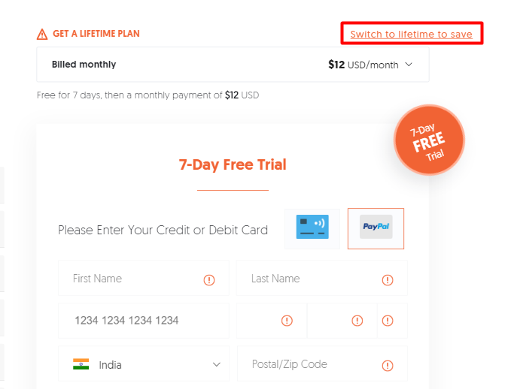

1. **It outside of boundary.. (When appears) Set margin**

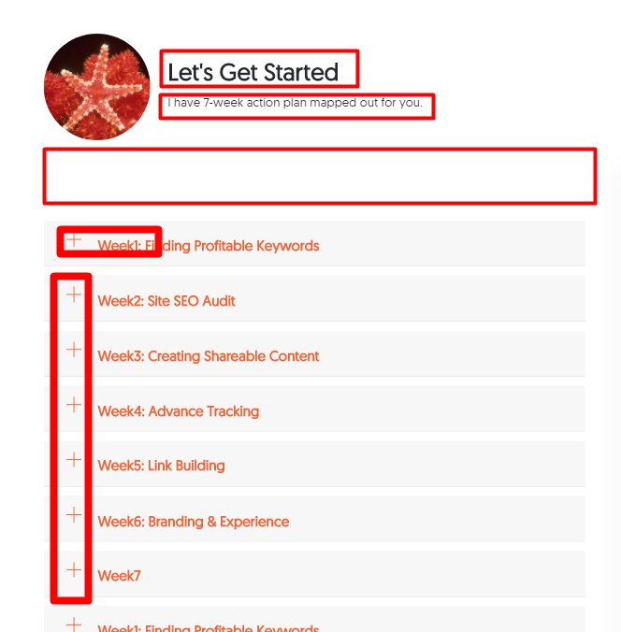

1. **Font size an font weight set**
2. **Font size an font weight set**
3. **Extra space remove top of the accordion section**
4. **In accordion set position of icon properly and there are no alt tag at Img**
5. **In accordion set position of icon properly and there are no alt tag at Img**

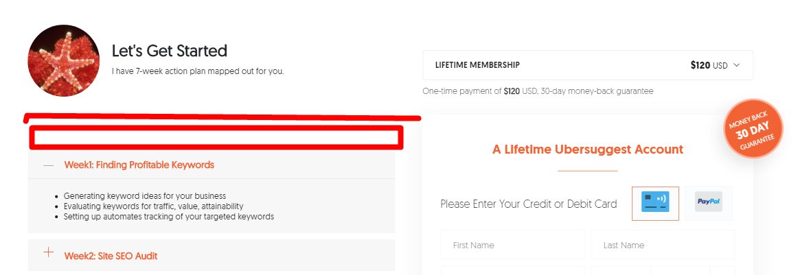

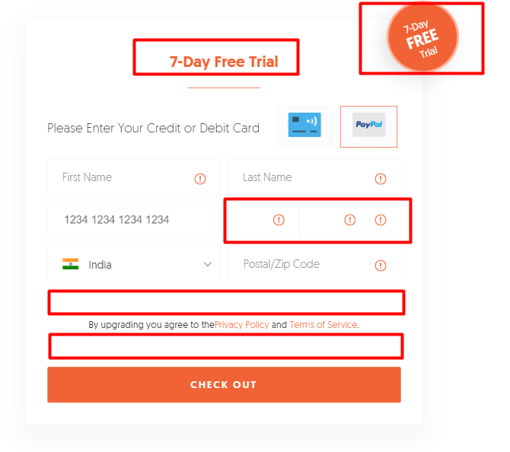

1. **Orange circle position changes (its flowing under from 80%)**
2. **Title font-size**
3. **MM YY CVV place holder missing (CVV box size very small compare to other two mm yy box)**
4. **Remove whitespce**
5. **Remove whitespce**

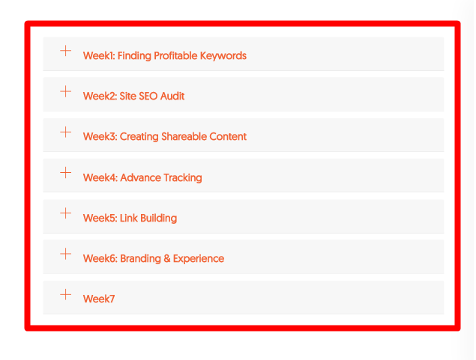

1. **Any time one and only one tab open(didn’t close all tabs)**

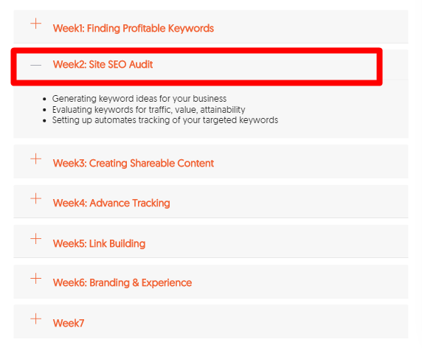

1. **If tabs active then header title colour changes and after word “week” then space and**

**Icon (+ and – position set correctly)**

**LAST images full screen of mockup ( Below page)**

**In their accordion add many times automatically when page update**

